Software Requirement Specifications
GeoSwap: A Proximity-Based Mobile Barter Radar System



Submitted by
Arifa S23BINFT1M01204
Submitted to
Mr. Wahaj Ali

Department of Information Technology
Faculty of Computing
The Islamia University of Bahawalpur
Summary
The GeoSwap Software Design Document (SDD) serves as the technical blueprint for developing a proximity-based mobile barter radar system, translating the functional and non-functional requirements from the SRS into a scalable architectural framework. The system architecture adopts a streamlined 3-tier approach, utilizing a cross-platform Flutter-based mobile frontend client for responsive map interactions, a unified asynchronous Python (FastAPI/Flask) backend server acting as the secure RESTful API provider, and a robust PostgreSQL database management tier enhanced with the PostGIS spatial extension to execute high-performance geospatial logic natively.
Key design considerations include the implementation of rigorous security protocols, such as AES-256 encryption for sensitive user data and coordinate "fuzzing" to ensure privacy, alongside database strategies designed to handle high concurrency and horizontal scaling. By detailing the data model schema through detailed Data Flow Diagrams (DFDs), an object-oriented Class Diagram, and an optimized interface design philosophy, this document establishes a structured technical foundation for the application development phase, ensuring the platform remains intuitive, reliable, and optimized for real-time local resource sharing.
Table of Contents
1. Introduction 4
1.1. Purpose 4
1.2. Scope 4
1.3. Product Perspective 4
1.4. User Characteristics 4
1.5. Similar apps and systems/Literature Review 4
1.6. Proposed Technologies 4
2. Requirements 5
2.1. Function Requirements 5
2.1.1. Sign Up 5
2.2. Non-Functional Requirements 5
3. Use Cases and Flow of Processes 6
3.1. Use Case 1 7
4. References 8

- Introduction
GeoSwap employs a three-tier layered architecture designed to decouple the user interface from business logic and data persistence, ensuring modularity and scalability.
  - Architectural Pattern
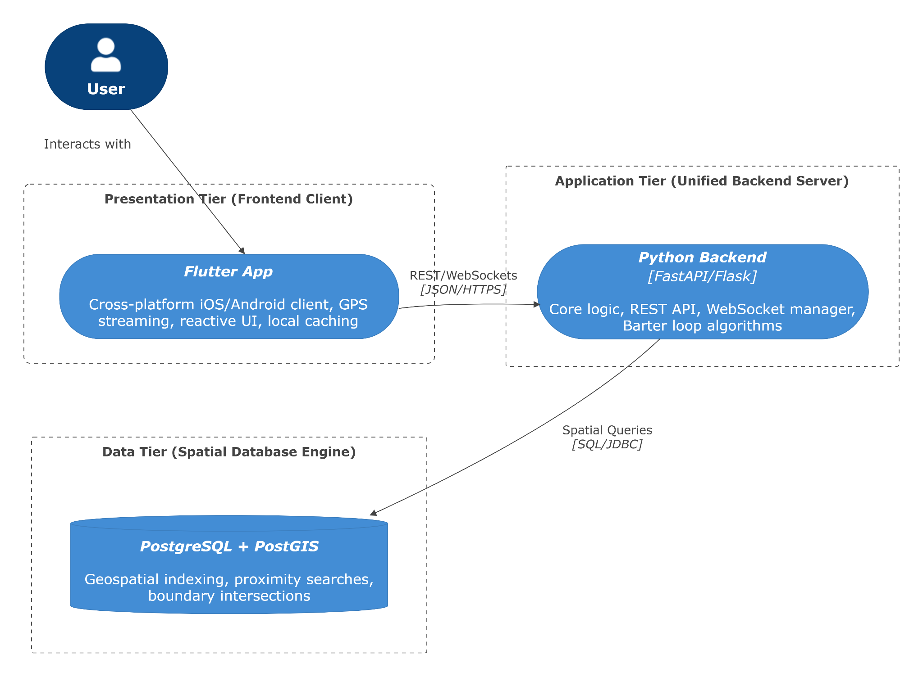
The technical design of the GeoSwap platform is built upon a highly optimized, decoupled 3-Tier Architecture designed to support real-time geospatial queries, low-latency mobile communication, and automated item matching. By separating the system into distinct presentation, application, and data management tiers, the platform ensures modularity, fault tolerance, and clean boundaries for scaling.
Figure 1.1: GeoSwap Three-Tier System Architecture
- Presentation Tier (Frontend Client): Developed utilizing the Flutter framework, this cross-platform client compiles natively for iOS and Android environments. It is solely responsible for rendering the reactive geographic radar interface, capturing hardware-level GPS coordinate streams, handling client-side caching, and managing asynchronous state changes.
- Application Tier (Unified Backend Server): Operating entirely within a single-backend Python environment (utilizing FastAPI or Flask), this layer hosts the platform's core application logic. It implements the security gateway, exposes standard RESTful API endpoints for synchronous mobile transactions, manages persistent WebSocket connections for live negotiations, and executes the mathematical multi-user barter loop algorithms.
- Data Tier (Spatial Database Engine): Consisting of a PostgreSQL database cluster supercharged by the PostGIS spatial engine extension. This tier abstracts high-computation geospatial operations away from the application layer, executing proximity searches, coordinate indexing, and boundary intersections directly at the database level.
  - Component Deconstruction
To translate the high-level three-tier architecture into a concrete development framework, the system is deconstructed into modular, functional software components. Each tier handles specialized operations and communicates across strict API boundaries to ensure low-latency performance and high data integrity.
    - Presentation Tier Components (Flutter Mobile Client)
The mobile client architecture isolates concerns by managing device hardware operations, local interface states, and network communication layers independently:
- Geospatial Radar Interface Module: Manages the custom rendering loops of the local map view, placing item markers visually based on proximity and dynamically handling smooth zoom and pan updates.
- Hardware Location Services Client: Hooks directly into the mobile device’s native GPS hardware subsystem to poll current coordinate strings while applying filtering algorithms to minimize device battery consumption.
- Authentication & Session Controller: Manages local storage tokens securely, tracking whether the application is running in a guest, pending, or fully verified operational context.
- Asynchronous Network API Client: Formats user actions into clean JSON payloads, dispatching asynchronous network requests up to the backend application server.
- Negotiation Streaming Client: Establishes and listens to full-duplex WebSocket channels, updating active text streams and trade states inside the user's view in real time.
    - Application Tier Components (Unified Python Backend Server)
The server architecture organizes its core processes into distinct, asynchronous modules running natively inside the single-backend Python environment:
- RESTful API Routing Gateway: Exposes secure network endpoints to receive HTTP payloads from the mobile frontend, handling request validation, error reporting, and JSON response encoding.
- Cryptographic & Security Controller: Handles token generation, runs password hashing logic, and executes AES-256 field-level decryption on coordinate values before processing them.
- Radar Engine Module: Acts as a lightweight data router that intercepts frontend coordinate vectors and builds fast SQL spatial queries to hand off to the database engine.
- WebSocket Stream Manager: Maintains thousands of concurrent, lightweight network streams, managing active message routing and connection drops inside the Negotiation Hub.
- Multi-User Barter Loop Engine: Executes the core background algorithm, periodically evaluating multi-user trade availability graphs when simple two-way trades are declined.
    - Data Tier Components (PostgreSQL + PostGIS Spatial Engine)
The database tier uses highly optimized relational tables configured specifically to offload heavy calculations away from the server logic layer:
- Relational Storage Schemas: Organizes structured tables for user profiles, items, matching logs, and chat histories with strict foreign key constraints.
- PostGIS Geometry Extension Layer: Encodes spatial location attributes directly as native geographic point data formats rather than standard floating numbers or text strings.
- Generalized Search Tree (GiST) Indexing: Implements specialized spatial indexes on coordinate columns to ensure high-speed spatial intersections and radius lookups execute in milliseconds.
  - Controller Functions and Core Sequence Logic
    - Core Controller Specifications
- Authentication & Registration Controller (auth_controller)
  - validateCredentials(phone, password): Enforces password complexity rules and checks format validation on phone strings.
  - processVerification(userId, documentPayload): Captures identity inputs and queues the account dataset for Data Entry Operator (DEO) or Admin approval.
- Spatial Inventory Controller (inventory_controller)
  - uploadItem(title, description, category, condition, imagePayload): Validates and processes item metadata text and image storage directories.
  - linkLocation(itemId, gpsData): Captures active coordinate strings and translates them into explicit PostGIS spatial features.
- Geospatial Radar Discovery Controller (radar_controller)
  - fetchNearbyItems(currentGps, searchRadius): Captures mobile device coordinates and executes native bounding queries to return items inside the defined distance parameter.
  - applyFilters(categoryEnum, conditionEnum): Sorts and screens active map markers based on user-selected listing types or state constraints.
- Negotiation & WebSocket Messaging Hub (negotiation_controller)
  - initiateSwap(senderId, receiverId, itemA, itemB): Creates a formal transaction log instance between two distinct participants.
  - sendChatMessage(msgPayload, sessionToken): Handles full-duplex, low-latency transmission within active chat streams.
- System Moderation Controller (moderation_controller)
  - flagContent(listingId, reasonCode): Appends warning metadata to listings and writes the tracking entry to the system audit store.
  - approveAccount(userId): Updates user verification parameters from pending to active status.
    - Real-Time Radar Discovery Sequence Flow
The interaction flow for local item discovery (UC003) is completely streamlined within the single-backend architecture, bypassing historical intermediary script bridges. The operational execution sequence follows this direct path:
- Request Initiation: The native Flutter mobile client polls the device's hardware location subsystem, captures the current coordinate array, and sends a direct asynchronous GET request containing the coordinates and the chosen search radius to the Python server engine.
- API Gateway Routing: The Python server (FastAPI/Flask) intercepts the incoming request payload, validates the user's active session token, and passes the location parameters directly to the Geospatial Radar Discovery Controller.
- Native Spatial Query Execution: The controller generates a highly optimized SQL query using native spatial functions (such as ST_DWithin) and dispatches it directly to the PostgreSQL database engine over a persistent database connection pool.
- Database Lookup: The PostgreSQL engine utilizes specialized Generalized Search Tree (GiST) spatial indices to instantly identify all item listings located within the specified distance threshold. It returns the filtered database records back to the Python backend in milliseconds.
- Privacy Fuzzing & Response: The Python controller loops through the returned results, applies a coordinate fuzzing calculation to protect the exact home addresses of listing owners, structures the item metadata into a clean JSON array, and sends it back to the mobile device.
- UI Rendering: The Flutter application client receives the JSON array payload and plots the item markers onto the interactive radar map interface.
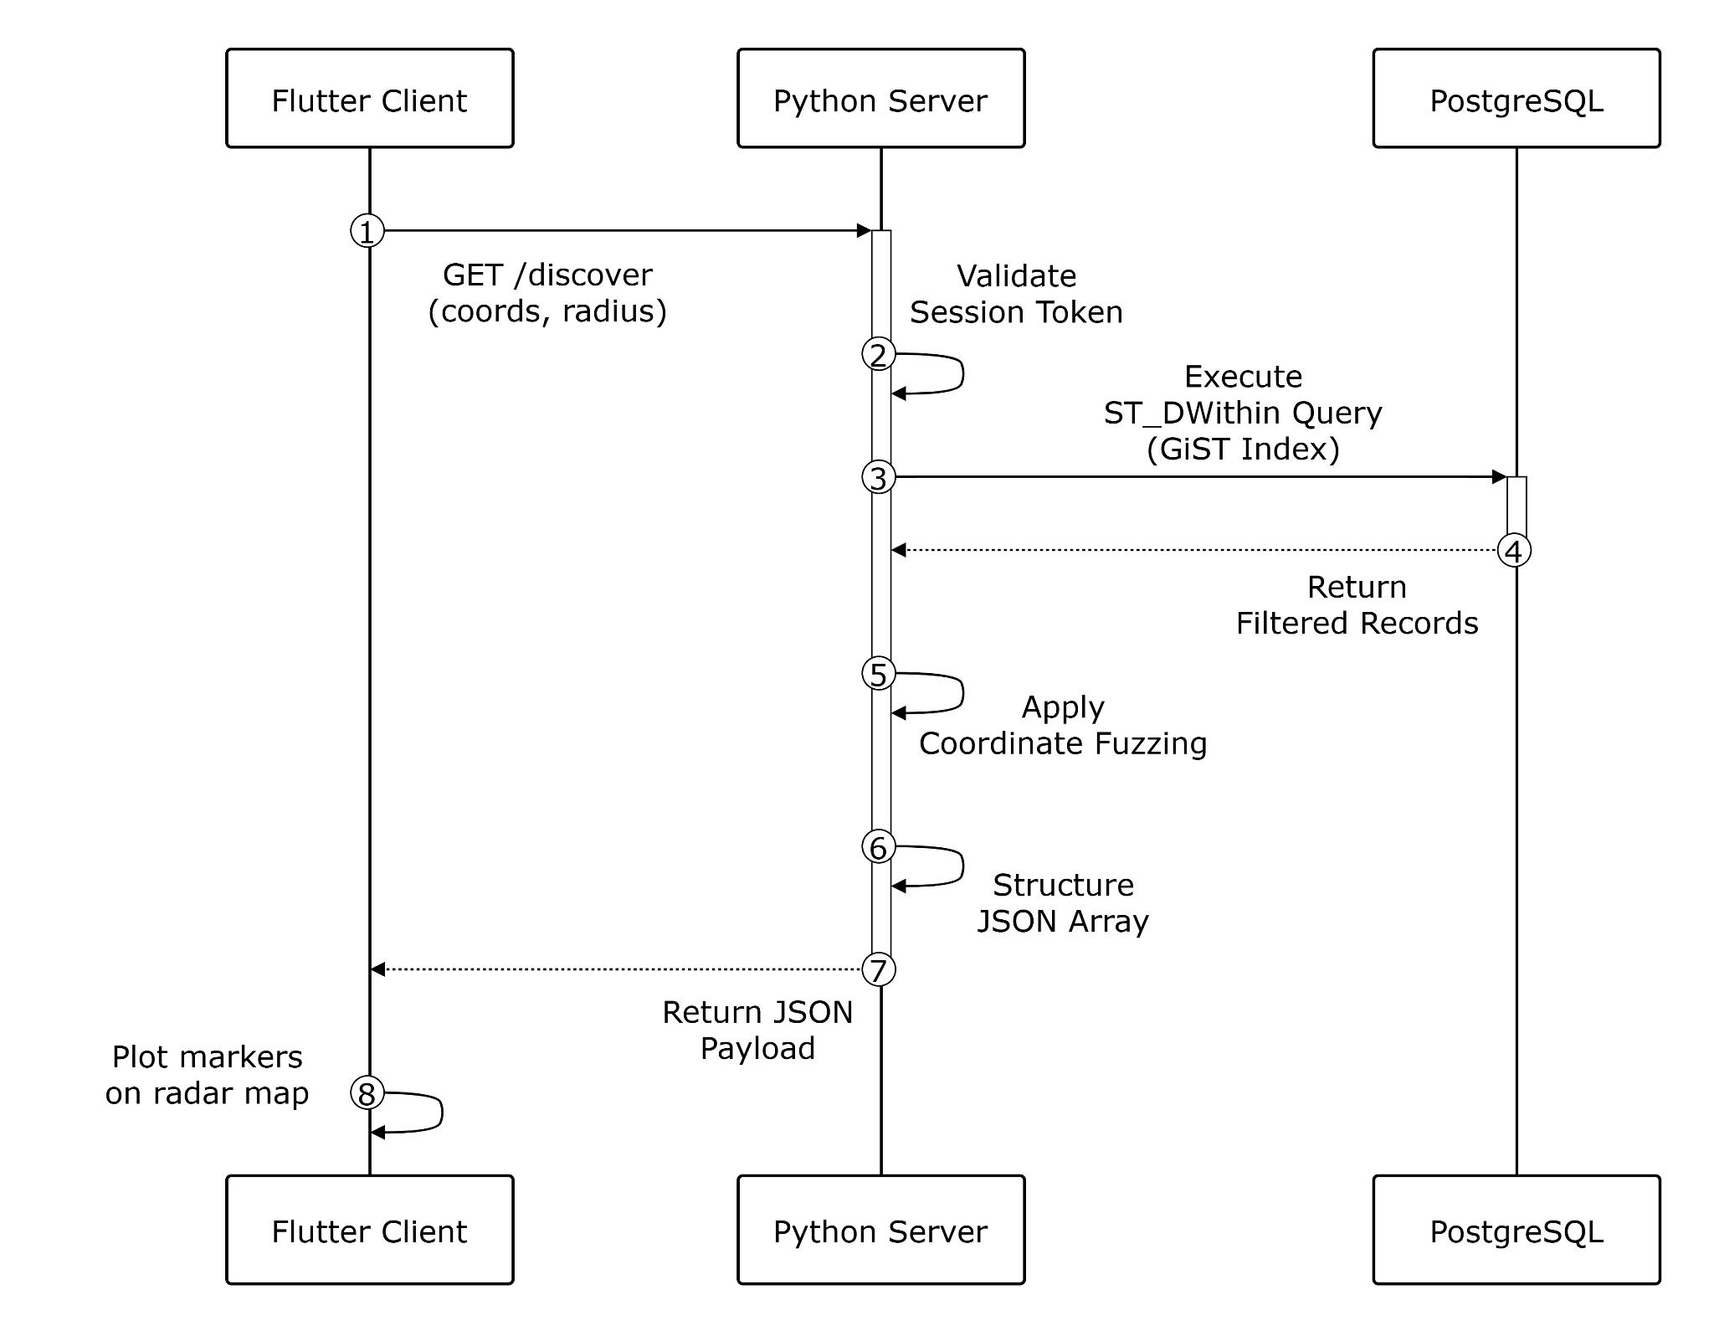
Figure 1.2: Sequence Diagram for Real-Time Radar Discovery (UC003)

  - API and Library Integration
To eliminate development redundancies, minimize system dependency overhead, and ensure near-zero latency execution times across the application lifecycle, the GeoSwap system framework integrates specific native APIs and standardized production-grade open-source libraries.
    - Backend Routing Framework API (FastAPI / Flask)
- Purpose: Serves as the single, authoritative application routing tier, processing incoming presentation requests without requiring an intermediary PHP script layer.
- Functionality: Implements automatic JSON data serialization and deserialization routines, handles secure multi-threaded connection pools, and enforces cryptographic session token verification rules natively at the gateway boundary.
    - Native Spatial Extension Engine (PostGIS)
- Purpose: Replaces basic computational coordinate math libraries (such as client-side script integrations of the Haversine formula).
- Functionality: Executes high-speed geographic queries directly within the PostgreSQL storage engine using optimized spatial classes and native indexing structures (such as ST_DWithin). This eliminates data transport lag between independent logical runtimes.
    - Mobile Location Services API (Flutter Geolocation Services)
- Purpose: Establishes a direct interface between the mobile user view and native system hardware.
- Functionality: Hooks directly into the Android Location API (via Google Play Services) and iOS CoreLocation subsystems to stream hardware-level GPS coordinate arrays into the Presentation Tier safely and with minimal device battery drain.
    - Real-Time Data Transport Protocol (IETF WebSockets)
- Purpose: Facilitates continuous, bidirectional communication channels inside the Negotiation Hub.
- Functionality: Implements the standardized RFC 6455 WebSocket Protocol directly inside the Python backend infrastructure. This allows instantaneous trade state synchronization, peer-to-peer message streams, and immediate push alerts without the overhead of heavy polling cycles.
    - Cryptographic Security Library (PyJWT & Cryptography)
- Purpose: Protects user privacy metrics and secures identity persistence across network nodes.
- Functionality: Handles secure AES-256 field-level symmetric block encryption for database record values and handles the automated generation and signature verification of stateless JSON Web Tokens (JWT) for authenticated API operations.
  - Coding Conventions
To ensure absolute maintainability, code readability, and seamless collaborative development throughout the application lifecycle, the GeoSwap project strictly enforces standardized architectural coding conventions across all development tiers.
    - Structural Naming Standards
- Presentation Tier (Flutter): Adheres to standard Dart linting guidelines. All variable names, function identifiers, and instance methods must utilize strict camelCase conventions. UI Widget classes and custom components must utilize PascalCase.
- Application Tier (Python): Enforces strict PEP 8 style compliance. All backend variable names, routing functions, and internal database connection queries must be written using lowercase snake_case.
    - Architectural and Interface Rules
- RESTful Clean Routines: All asynchronous endpoints exposed by the Python API must bind strictly to standard HTTP methods. Data retrieval operations must use GET, record creations must use POST, status or listing modifications must use PUT, and cancellations or listing removals must use DELETE.
- Decoupled Security Boundaries: To keep the native mobile client highly responsive, all heavy resource computations—including multi-user barter loop processing, cryptographic hashing, and intensive PostGIS distance intersections—must execute entirely on the server side. The mobile frontend is restricted to rendering data and capturing hardware location arrays.

- Data Flow Diagrams (DFDs)
  - Level 0 DFD (Context Diagram)
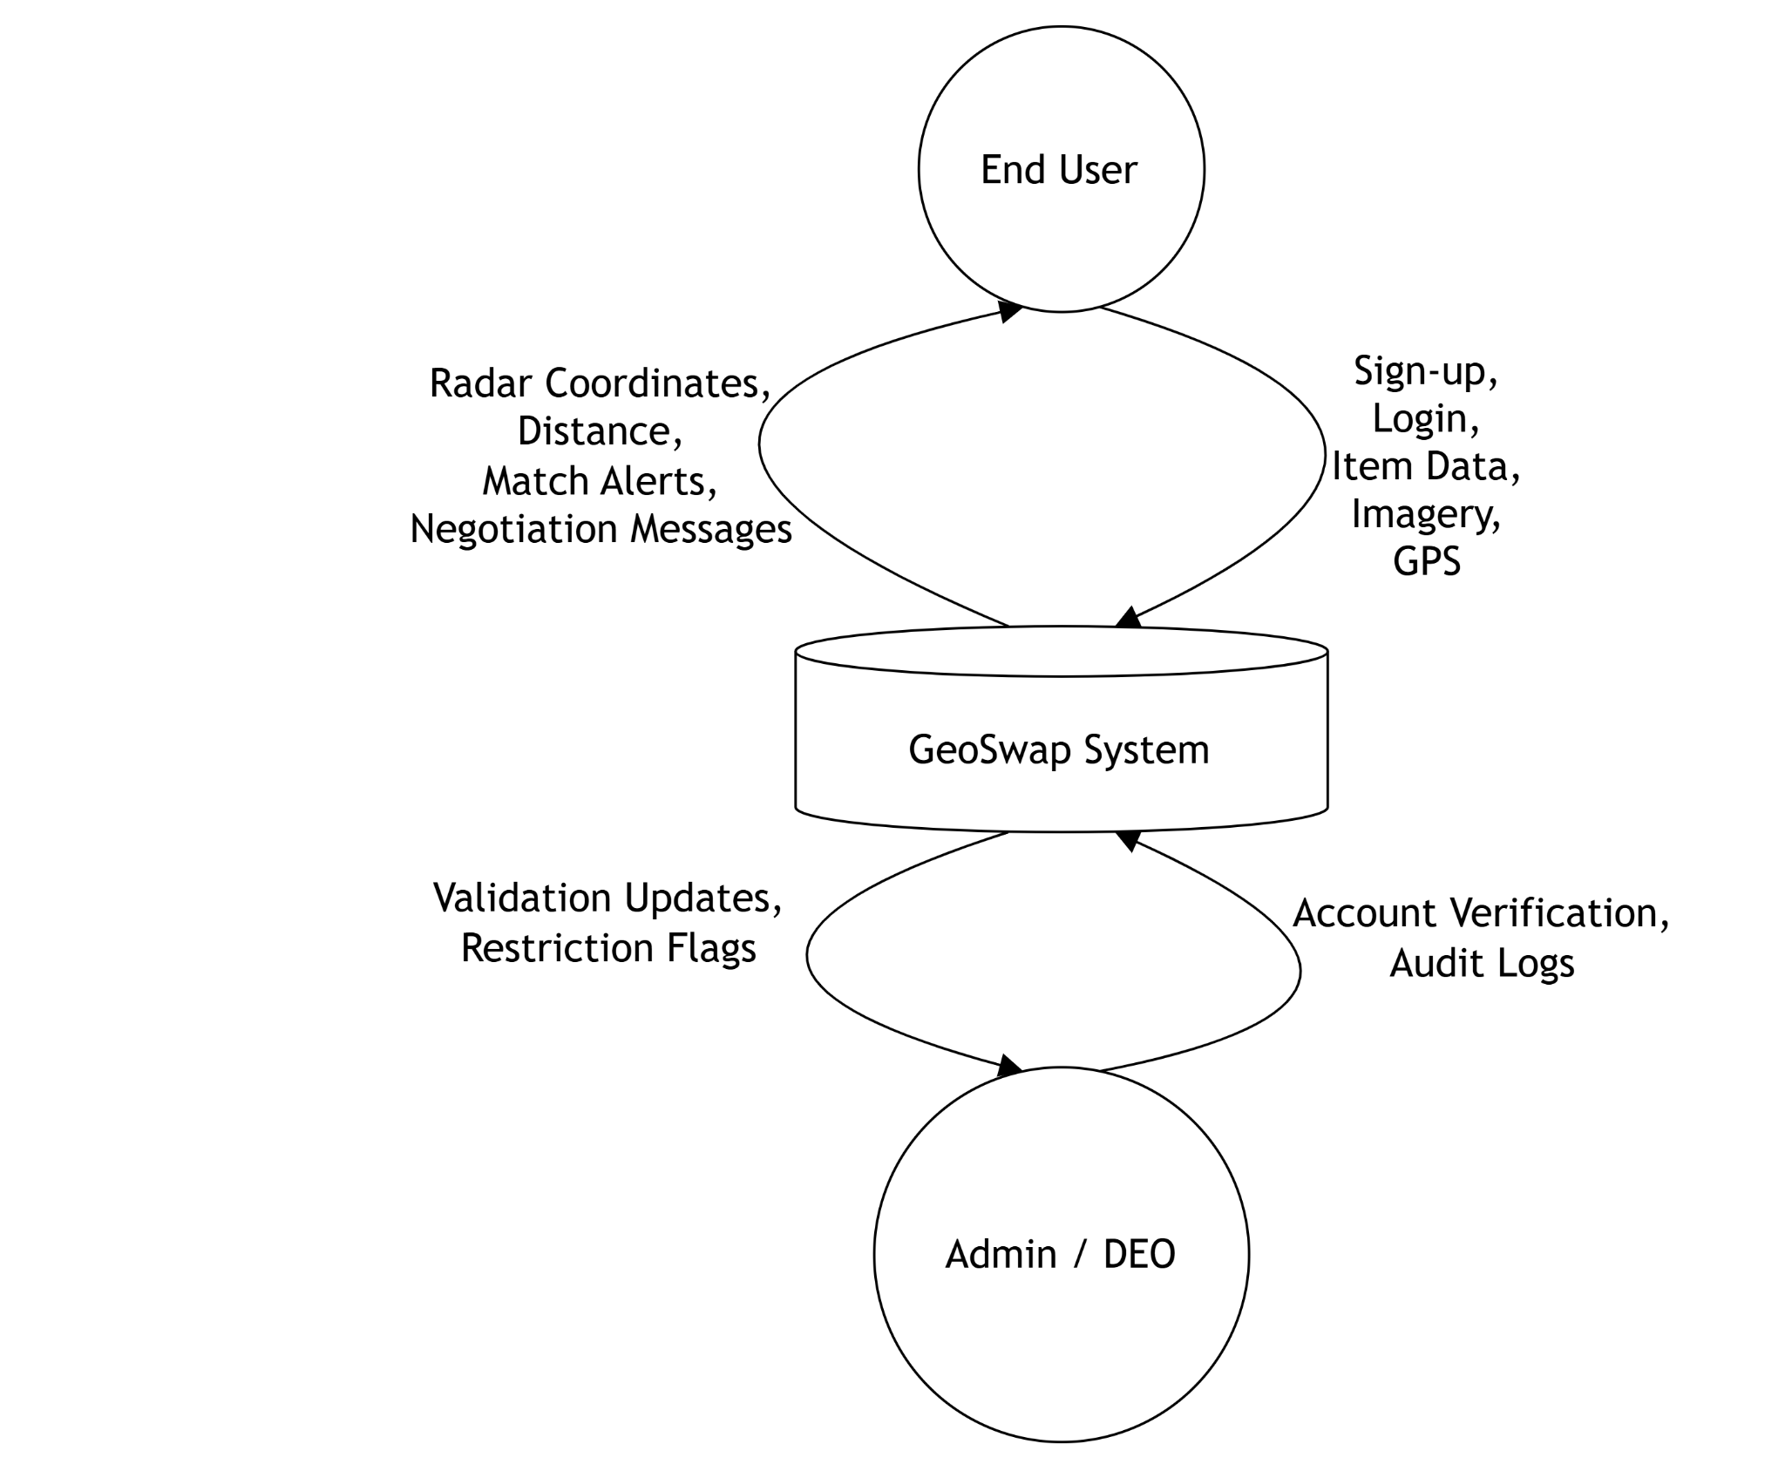
The Level 0 Data Flow Diagram establishes the fundamental boundary of the GeoSwap application ecosystem. It models the entire system as a centralized single operational process block, detailing the structural data streams between the application boundary and external entities—specifically the general End Users and the System Administrator/Data Entry Operator (DEO)—without exposing internal database schemas or programmatic execution paths.
Figure 2.1: Level 0 Context Data Flow Diagram (DFD)
    - Process Decomposition and Data Streams
- User-to-System Input Streams: The mobile end-user transmits sign-up vectors, account login credentials, item descriptions with specific category tags, high-resolution item imagery payloads, and active hardware-level GPS coordinate streams into the central system process boundary.
- System-to-User Output Streams: The system processes data vectors and transmits real-time spatial radar coordinates, calculated distance buffers, active trade match alerts, and direct peer-to-peer negotiation message packets back to the mobile client view layer.
- Administrative Operations: The System Administrator or DEO interfaces with the system boundary to pull pending account verification queues, audit logs, and issue validation updates or content restriction flags.
  - Level 1 DFD (Detailed Functional Breakdown)
The Level 1 Data Flow Diagram breaks the core system down into its four primary backend functional processes running natively within the unified Python environment. It documents how incoming mobile data streams are routed through logical validation steps, transformed, and written into or read from specific persistent data stores within the PostgreSQL database tier.
    - Process 1.0: User Authentication & Verification Manager
- Description: This process captures incoming registration and login payloads from the client network interface. It executes secure background password hashing, coordinates identity verification pipelines, and creates user profile records.
- Data Store Interactions: Writes new user vectors to and verifies active session credentials against the Profiles Data Store (D1).
    - Process 2.0: Spatial Item Inventory Management
- Description: This process manages the creation, modification, and status tracking of assets listed for bartering. It parses incoming text description inputs, maps uploaded image storage paths, and binds the owner's account metadata to the listed item.
- Data Store Interactions: Formats asset records and writes them directly to the Geospatial Listings Data Store (D2).
    - Process 3.0: Geospatial Radar Discovery Engine
- Description: This high-frequency operational process handles real-time proximity searching. It intercepts the mobile client’s active GPS coordinate array and selected search radius, passing those variables down to execute bounding spatial intersection lookups.
- Data Store Interactions: Executes read-only spatial index queries against the Geospatial Listings Data Store (D2) using native PostGIS spatial functions.
    - Process 4.0: Negotiation Hub & Loop Matching Engine
- Description: Manages the communication channels and active swap agreements between users. It coordinates persistent WebSocket streams to sync instant text messaging payloads and trade states. Simultaneously, it triggers background algorithms designed to trace multi-user barter paths when direct two-way trades are unavailable.
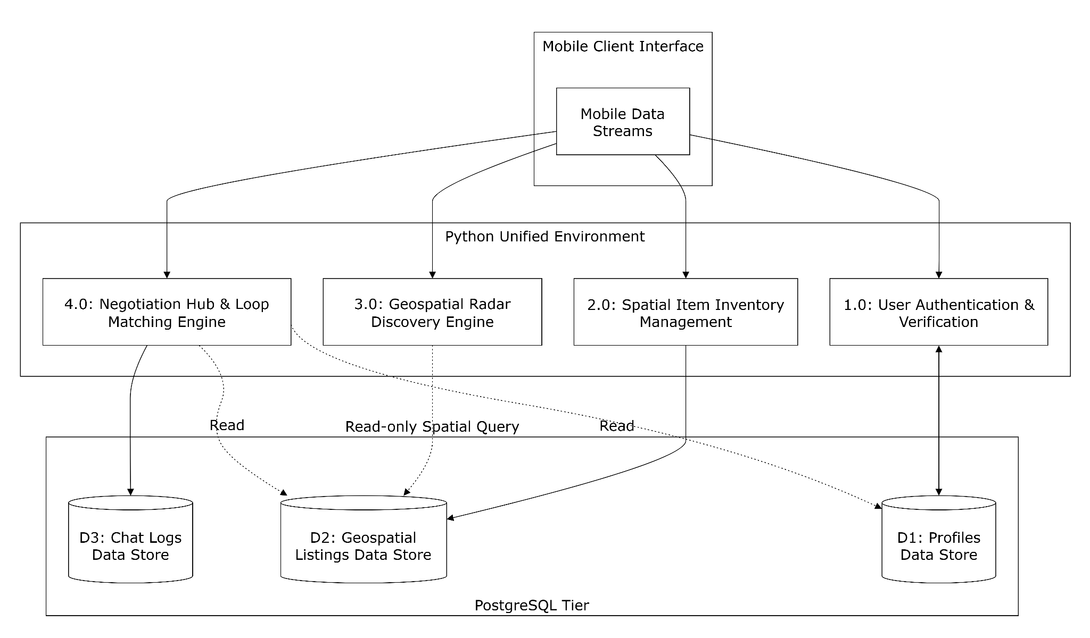
- Data Store Interactions: Appends persistent messaging logs to the Chat Logs Data Store (D3) and reads from both D1 and D2 to map complex alternative trade chains.
Figure 2.2: Level 1 Data Flow Diagram (DFD)
- Data Model Schema
  - Relational Database Philosophy
The data tier of the GeoSwap application utilizes a robust relational database model implemented within an enterprise-grade PostgreSQL database management system. This relational structure is designed to preserve absolute referential integrity, enforce data consistency constraints across all operational modules, and prevent transactional data anomalies during high-concurrency mobile workloads.
The defining technical advantage of the GeoSwap data model is the native integration of the PostGIS spatial engine extension. Rather than utilizing external programmatic script loops at the application server layer to approximate location metrics (such as the Haversine formula), the database tier handles all complex geometric vector algebra natively. By utilizing specialized spatial data types and Generalized Search Tree (GiST) spatial indices, proximity radius calculations and boundary intersections execute directly within the storage engine core, returning results in milliseconds.
  - Data Dictionary and Table Structures
The following database schemas define the precise structure, constraints, data types, and nullability rules of the storage layer. To protect system security and user privacy, all physical device coordinates are securely encapsulated within native geographic point object types rather than unsafe flat floating-point strings.
    - Users Table
Attribute Name | Data Type | Constraints | Description
user_id | SERIAL | PRIMARY KEY | Unique autoincrementing system identifier for each participant.
full_name | VARCHAR(100) | NOT NULL | The verified profile name of the registered user.
phone_number | VARCHAR(20) | UNIQUE, NOT NULL | The primary contact number used as the unique authentication login key.
password_hash | VARCHAR(255) | NOT NULL | Cryptographically hashed password text string (using bcrypt/Argon2).
home_address | TEXT | NOT NULL | Physical address details utilized for background verification checks.
profile_status | VARCHAR(20) | DEFAULT 'Pending' | Account operational control state (Pending, Verified, Suspended).
account_role | VARCHAR(20) | DEFAULT 'User' | System access privilege tier limits (User, DEO, Admin).

    - Item Listings Table
Attribute Name | Data Type | Constraints | Description
item_id | SERIAL | PRIMARY KEY | Unique identifier for the specific barter marketplace listing.
owner_id | INT | FOREIGN KEY REFERENCES users(user_id) | Maps the item listing directly back to its verified owner.
title | VARCHAR (150) | NOT NULL | The descriptive title of the listed asset.
description | TEXT | NOT NULL | Detailed description outlining item features and exchange preferences.
category | VARCHAR(50) | NOT NULL | Predefined classification filter group (e.g., Electronics, Books, Fashion).
item_condition | VARCHAR(30) | NOT NULL | Standardized wear metric description indicating physical state.
geo_location | GEOGRAPHY (Point, 4326) | Spatial Index (GiST) | Natively stores latitude and longitude values inside a PostGIS spatial coordinate point.
image_path_1 | VARCHAR (255) | NOT NULL | Server directory path URL for the primary item image upload.
image_path_2 | VARCHAR (255) | NULL | Server directory path URL for an optional secondary item image upload.
listing_status | VARCHAR(20) | DEFAULT 'Available' | Current asset market state control (Available, Reserved, Swapped).

    - Swap Transactions Table
Attribute Name | Data Type | Constraints | Description
trans_id | SERIAL | PRIMARY KEY | Unique transaction identifier for the barter agreement instance.
sender_id | INT | FOREIGN KEY REFERENCES users(user_id) | Identifies the user originating the barter trade proposal.
receiver_id | INT | FOREIGN KEY REFERENCES users(user_id) | Identifies the targeted user receiving the barter proposal.
item_a_id | INT | FOREIGN KEY REFERENCES listings(item_id) | The specific listing asset offered by the transaction initiator.
item_b_id | INT | FOREIGN KEY REFERENCES listings(item_id) | The targeted listing asset requested from the receiver's inventory.
trans_status | VARCHAR(20) | DEFAULT 'Pending' | The current lifecycle state of the deal (Pending, Accepted, Completed).
created_at | TIMESTAMP | DEFAULT CURRENT_TIMESTAMP | System record creation timestamp.

    - Chat Messages Table
Attribute Name | Data Type | Constraints | Description
msg_id | SERIAL | PRIMARY KEY | Unique autoincrementing identifier for the individual message.
trans_id | INT | FOREIGN KEY REFERENCES transactions(trans_id) | Links the conversational message line directly to its parent transaction.
sender_id | INT | FOREIGN KEY REFERENCES users(user_id) | Tracks which participant generated the text content string.
content | TEXT | NOT NULL | The encrypted plain text conversational message payload.
sent_at | TIMESTAMP | DEFAULT CURRENT_TIMESTAMP | Automated transmission timing record.

    - System Audit Logs Table
Attribute Name | Data Type | Constraints | Description
log_id | SERIAL | PRIMARY KEY | Unique identifier tracking the system administrative event.
actor_id | INT | FOREIGN KEY REFERENCES users (user_id) | The specialized Admin or DEO account authorizing the action.
target_item_id | INT | FOREIGN KEY REFERENCES listings(item_id) | The specific database listing audited or restricted.
action_taken | VARCHAR (100) | NOT NULL | Modifying label description (e.g., Account Verification, Listing Ban).
reason | TEXT | NOT NULL | Mandatory administrative text detailing policy justification.
logged_at | TIMESTAMP | DEFAULT CURRENT_TIMESTAMP | Exact system execution clock timestamp.

  - Entity Relationship Analysis
The operational architecture relies on structural cardinality rules to protect referential database safety across the schema boundaries:
- User to Listings (1 : N): A single user profile can create and manage an infinite number of active barter item listings over time, but every single listing must be mapped strictly to exactly one owning user account.
- User to Transactions (1 : N): An individual participant can participate simultaneously in multiple swap negotiations as either an initiator or a recipient, linking their single user identifier to multiple transaction logs.
- Listings to Transactions (1 : N): An individual listed item can be included as a proposed asset across multiple concurrent transactional negotiation sessions, but it can only be marked as successfully swapped within one final finalized deal record.
- Transaction to Chat Messages (1 : N): A single initiated swap instance serves as the definitive parent room container for zero, one, or thousands of individual real-time text message rows streaming through WebSockets.
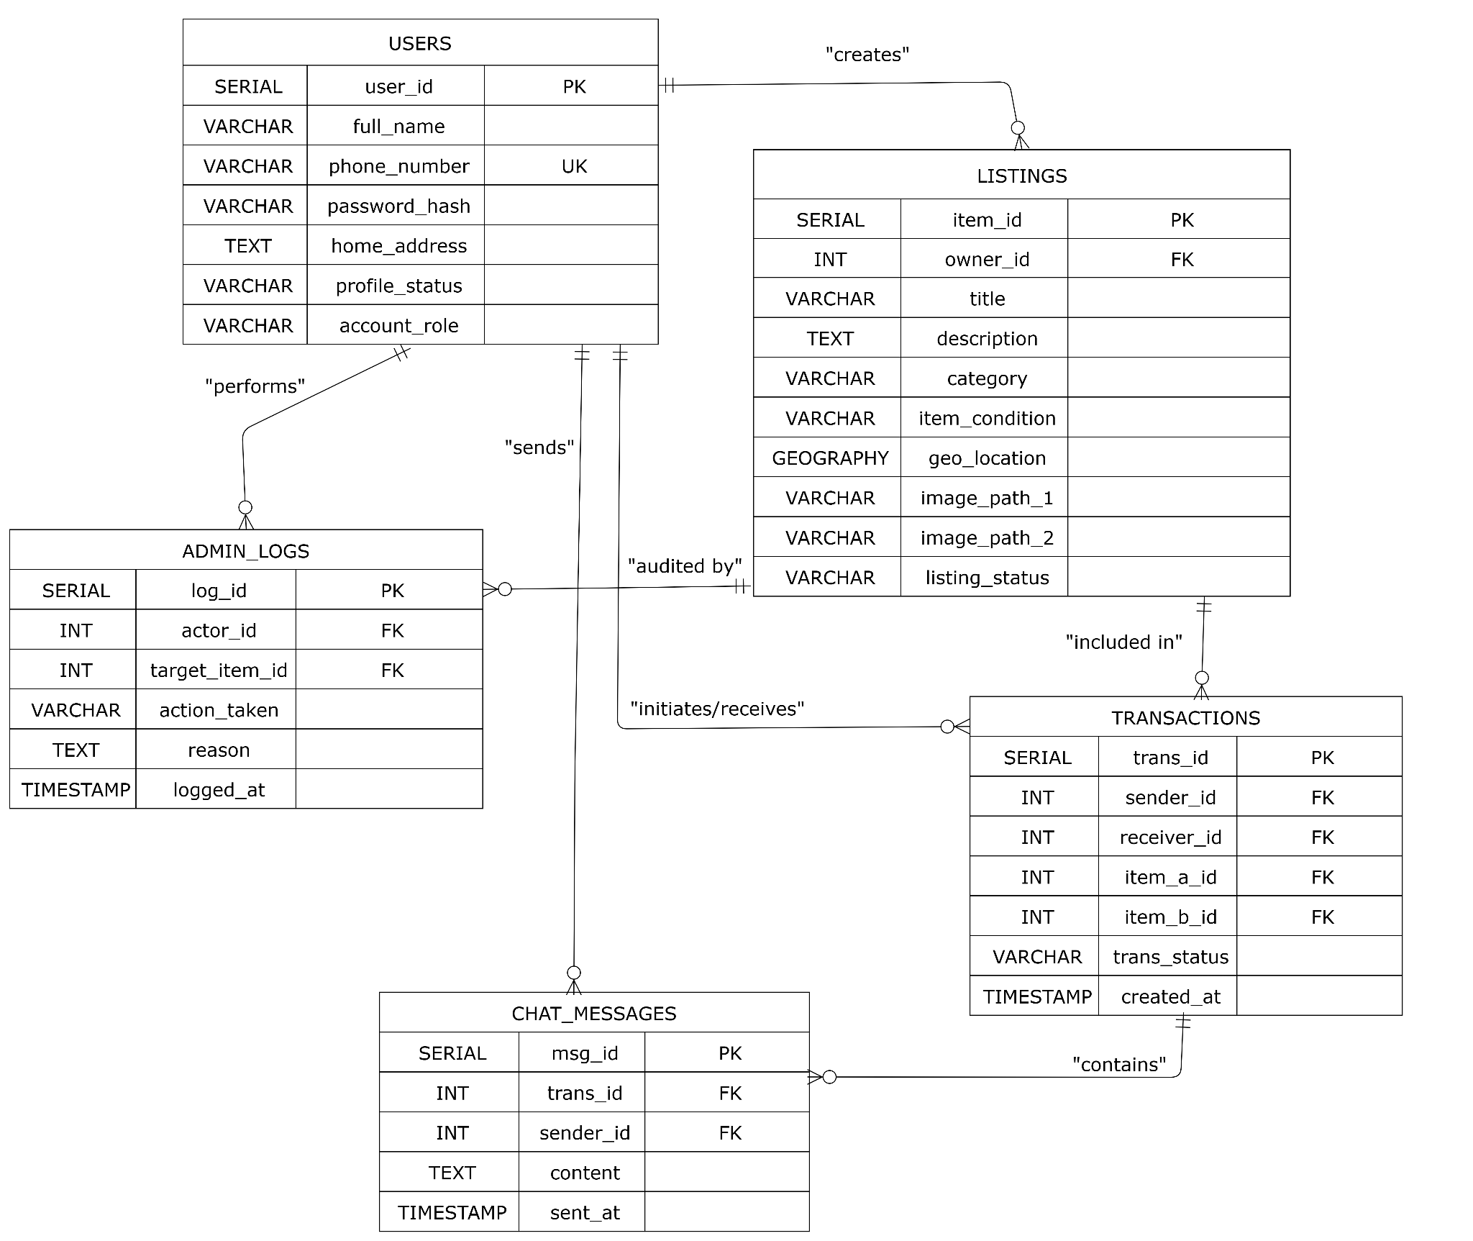

Figure 3.1: Physical Entity-Relationship Diagram (ERD) with PostGIS Spatial Encodings and Structural Foreign Key Constraints

- Object Oriented Class Diagram
  - Class Diagram Philosophy
The structural architecture of the GeoSwap application is modeled using object-oriented design principles. This chapter bridges the logical data models and real-time backend routines by organizing the platform into concrete, modular classes. These classes encapsulate specific data attributes and state-manipulation methods, isolating responsibilities across system boundaries to optimize memory utilization and runtime efficiency.
The system's classes are divided into two main domains:
- Entity Classes: High-level models mapping directly to your relational PostgreSQL tables, handling data validation and serialization routines.
- Controller Classes: Asynchronous execution wrappers that handle the application's core logic, location processing, and communication channels.
  - Class Specifications and Attributes
The object-oriented design leverages explicit type definitions and accessor configurations to maintain low-coupling across system components:
    - Core Entity Models
- User Class
  - Attributes: int userId (Private), String fullName (Public), String phoneNumber (Public), String passwordHash (Private), String homeAddress (Public), String profileStatus (Public), String accountRole (Public).
  - Methods: bool validateSession(), Map toJson(), User fromJson(Map data).
- Listing Class
  - Attributes: int itemId (Private), int ownerId (Private), String title (Public), String description (Public), String category (Public), String itemCondition (Public), Object geoLocation (Private - PostGIS Object), String imagePath1 (Public), String imagePath2 (Public), String listingStatus (Public).
  - Methods: bool updateStatus(String newStatus), double calculateFuzzedDistance(Object viewerLocation).
- Transaction Class
  - Attributes: int transId (Private), int senderId (Private), int receiverId (Private), int itemAId (Private), int itemBId (Private), String transStatus (Public), DateTime createdAt (Public).
  - Methods: bool updateTransactionState(String statusEnum), bool compileReceipt().
- ChatMessage Class
  - Attributes: int msgId (Private), int transId (Private), int senderId (Private), String content (Public), DateTime sentAt (Public).
  - Methods: bool encryptPayload(), Map serializeMessage().
    - Core Operational Controllers
- RadarController Class
  - Attributes: Object systemGpsClient, int searchRadiusThreshold.
  - Methods: List<Listing> fetchNearbyItems(Object currentGps, int radius), List<Listing> executeCategoryFilter(String categoryFilter).
- NegotiationController Class
  - Attributes: Object webSocketManager, List<Transaction> activeSessions.
  - Methods: void establishStreamChannel(int transId), bool broadcastMessage(Object messagePayload), void executeMultiUserLoopCheck().
  - Class Interdependencies and Relationships
The dependencies between classes enforce systemic guardrails to ensure stable runtime states:
- Composition (1 to *): A Transaction object maintains a composition relationship with ChatMessage objects. A chat room instance acts as the structural parent container for message blocks; if a transaction session is dropped or deleted from memory, its associated active message runtime arrays are cleared.
- Association (1 to *): The User class holds an association link with the Listing class. A user object can reference multiple item listings inside an array, while each listing object maps back to a single primary owning user.
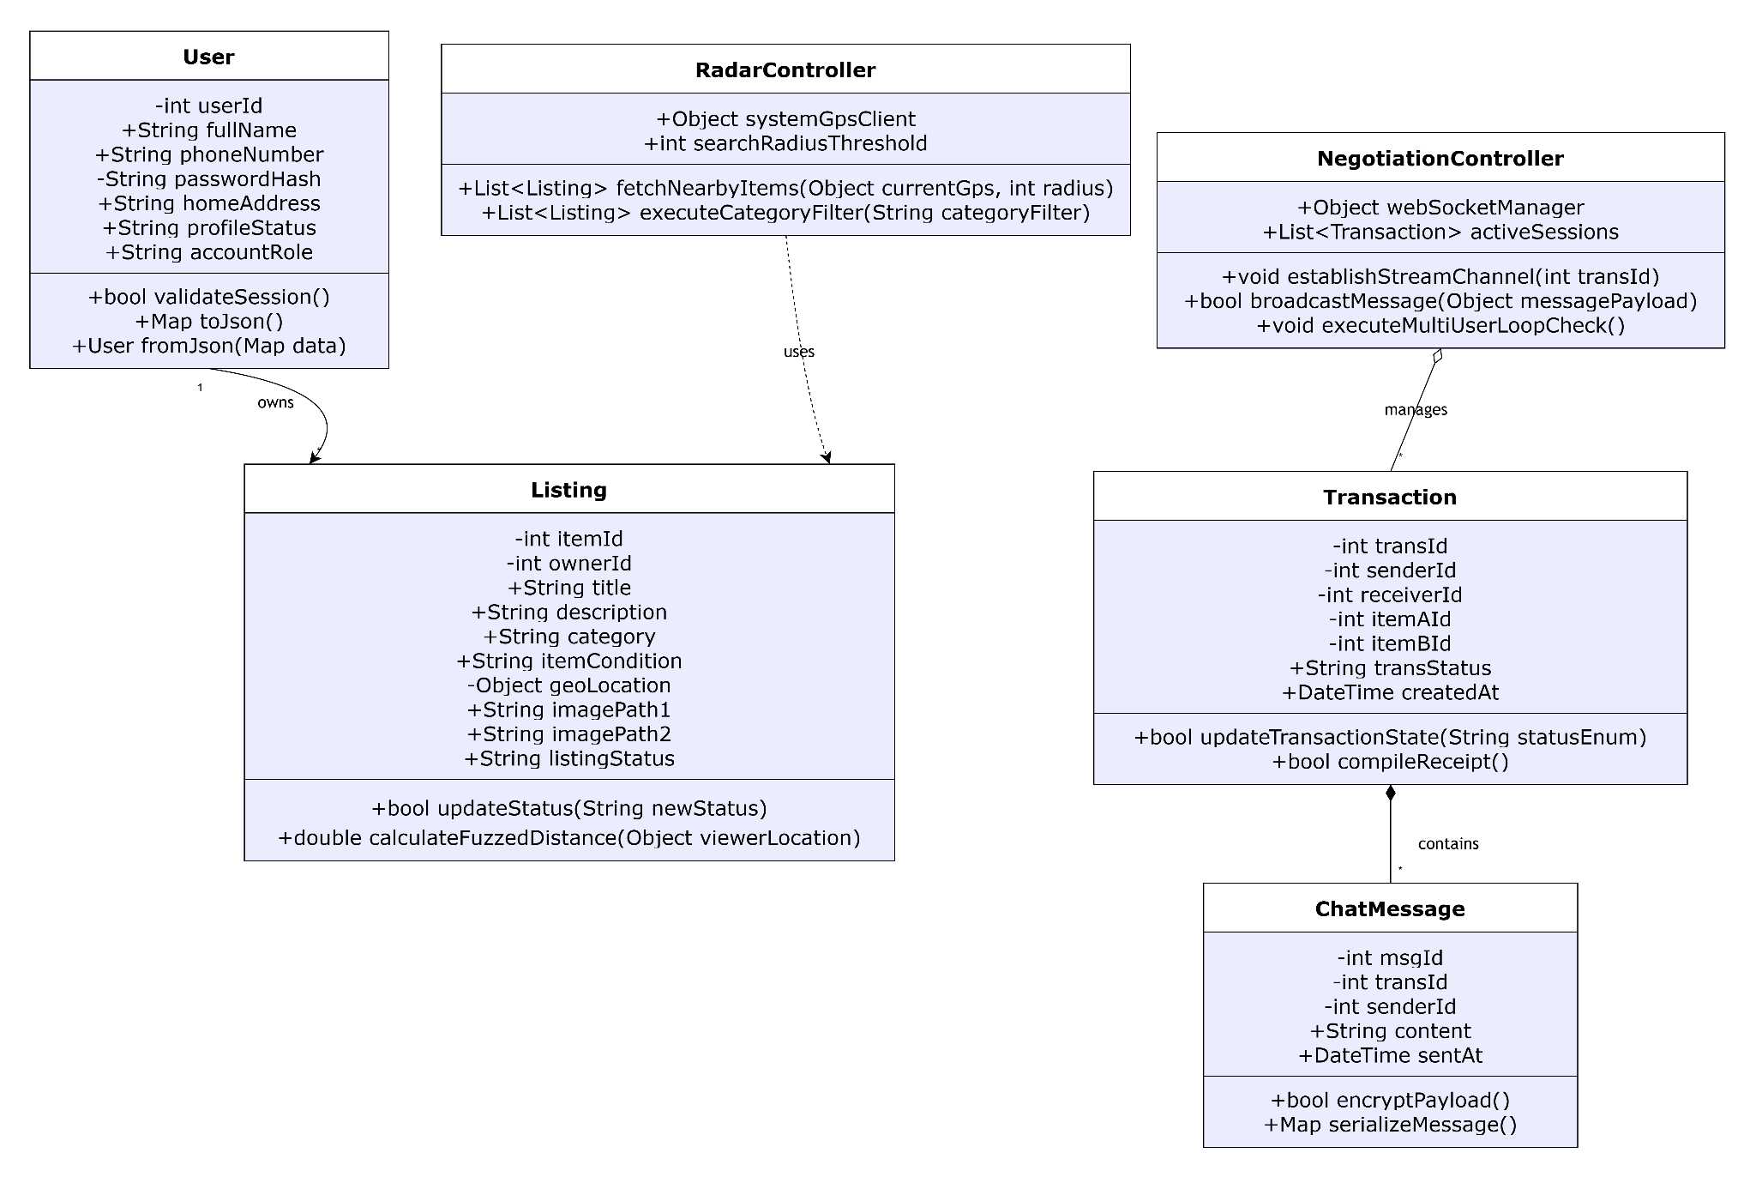
- Dependency: The RadarController class maintains an operational dependency on the Listing class. It continuously parses arrays of listing instances, extracts their coordinate attributes to apply location privacy equations, and streams the transformed metadata arrays down to the presentation layer.

Figure 4.1: Unified Modeling Language (UML) Class Diagram Detailing Object-Oriented Entity Models, Controller Methods, and Class Associations.
- User Interface Design And Screen-Level Logic
  - UI Design Philosophy and Visual Hierarchy
The GeoSwap presentation layer is designed to offer a seamless, high-performance, and intuitive mobile interface built entirely within the Flutter framework. The user interface (UI) principles prioritize minimal cognitive load, rapid access to core bartering features, and immediate visual feedback during high-frequency tasks such as item discovery and live chat.
The visual system enforces an active card-based and map-centric layout structure. Primary application actions—such as searching for nearby items or checking swap alerts—are positioned within easy reach of a single thumb. Elements like system statuses, verification states, and listing tags utilize explicit color coding (e.g., Green for Available/Verified, Amber for Pending, and Blue for Active Negotiation) to ensure high scannability across all screen contexts.
  - User Interface Navigation Map
The structural arrangement of the mobile application follows a decoupled hierarchical architecture, preventing deeply nested routing channels and ensuring efficient memory management across the interface states:
- Authentication Hub (Gateway Screen): Serves as the mandatory system entry point. Directs unauthenticated traffic into the Secure Registration Module or the Account Login Panel. Upon verification of session tokens, routing is handed off to the main application navigation cluster.
- Central Navigation Dashboard: A persistent bottom navigation layout managing four core operational views:
  - Geospatial Radar Screen: The primary map interface showing real-time item discovery.
  - Item Inventory Marketplace: A grid layout containing active listings categorized by user filter choices.
  - Active Negotiation Matrix: A unified dashboard tracking inbound, outbound, and multi-user swap pipelines.
  - Verified Profile Console: Manages personal preferences, account identity statuses, and administrative audit logs for DEO accounts.
  - Screen-Level Functional Logic
To maintain high performance and low latency on the mobile client, heavy calculations are offloaded entirely to the server side. The client screens function primarily as views that render data and capture hardware states.
    - Proximity Radar Screen Logic
- Hardware Initialization: Upon loading, the screen requests runtime device permission strings from the operating system's native geolocation subsystem.
- Asynchronous Polling Routine: The view captures the hardware latitude and longitude coordinates. Instead of running a client-side Haversine script, it transmits these raw parameters alongside the user's selected radius via an asynchronous GET request directly to the backend radar_controller.
- Render Execution Layer: When the server returns the filtered JSON payload, the screen clears old local states, converts the item coordinates into graphical map pins, and applies a privacy-protecting fuzzing offset to ensure individual home addresses are never exposed directly on the map interface.
    - Real-Time Chat & Stream Synchronization Screen Logic
- Connection Layer: Launching a specific transaction chat screen triggers the client to establish a secure, full-duplex WebSocket connection via the backend negotiation_controller.
- State Transmission Rule: Typing states and text payloads are serialized instantly into lightweight JSON packets and pushed over the open socket connection, bypassing heavy HTTP request-response overhead.
- Dynamic UI Updates: The screen uses reactive stream listener objects to automatically append incoming text lines to the chat window and update trade status fields in real time without refreshing the page.
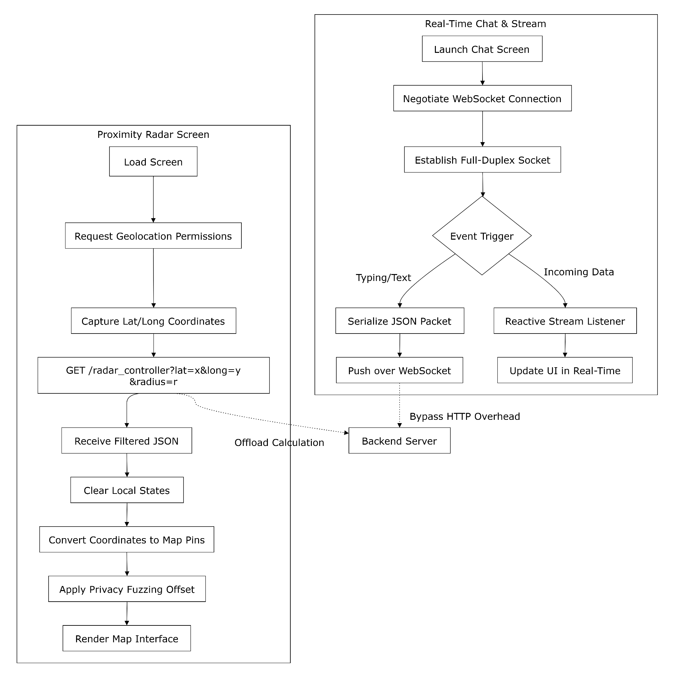
Figure 5.1: Unified Modeling Language (UML) Class Diagram Detailing Object-Oriented Entity Models, Controller Methods, and Class Associations.
6. Conclusion
The Software Design Document (SDD) for the GeoSwap platform provides a complete, technically rigorous engineering blueprint for a modern, proximity-based mobile barter ecosystem. By transitioning the core architecture away from traditional, resource-heavy frontend computations to a clean, decoupled Three-Tier Architecture—driven by a responsive Flutter client, a robust Python application backend, and a high-performance PostgreSQL database optimized with PostGIS extensions—the system guarantees structural stability, low latency, and enterprise-grade security bounds.
Through the systematic modeling of data flow streams (DFDs), object-oriented class interactions (UML), and rigorous field-level relational schemas, this design addresses all critical operational requirements, including multi-user trade loop matching and privacy-protected spatial radar discovery. Ultimately, this document serves as the definitive structural foundation for the implementation, validation, and successful deployment of the GeoSwap application, meeting both modern software engineering standards and academic evaluation criteria.

